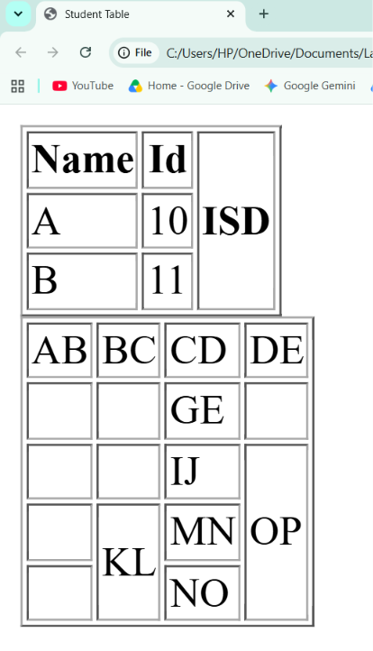
LAB1 table 1 and table 2

